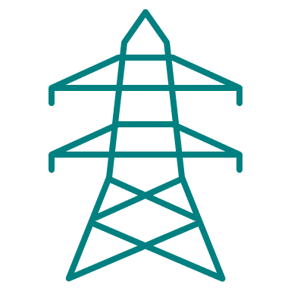
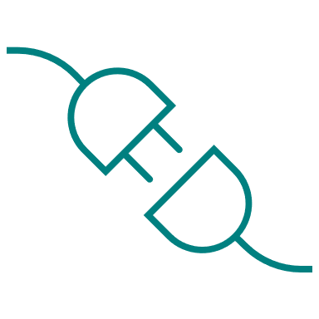
Grid Capacity Review
Scrutiny Committee Task & Finish Group
Glossary (v1.0)

Balancing: The operational process of ensuring that supply matches demand. Failure to balance risks power cuts or a change in frequency in the grid (which can cause equipment failure). This is currently undertaken nationally by National Grid ESO, but is increasingly becoming a role of local distribution network operators – which is known as ‘the DNO-DSO transition’.
Baseload power: The permanent minimum load that a power system needs to deliver.
Bulk Supply Points (BSPs): An Intermediate-level substation where 132kV is transformed to 33kV.
Capacity: The maximum wattage output of an electricity generator (e.g. a wind turbine or power plant) of the grid (i.e. the maximum wattage it can incorporate). Where the grid lacks sufficient capacity to absorb new connections this is a ‘capacity constraint’, and may require grid reinforcements/upgrades or better use of flexibility measures.
Capacity Margin: This is the excess of installed generation capacity on the network above peak-level demand.
Capacity Market: The competitive auction that pays successful bidders to provide extra supply capacity to the grid if required.
Consumer-owned energy resource (CER): ‘CER’ denotes household demand, storage and generation assets, such as EV chargers, heat pumps, white goods, rooftop solar or wind, and batteries.
Curtailment: The removal of a generator from the grid to help with balancing to help balance supply and demand, and for which a generator can be paid a constraint payment.
Decentralisation: The trend of a movement from centralised large energy generators directly connected to the transition network, toward the connection of a larger number of smaller, local generation and storage assets directly into the distribution grid.
Demand side response: Consumer action to limit energy consumption during times of peak demand, usually through direct payments or time of use tariffs.
Distributed energy resources (DERs): ’DER’ denotes the generation, generation and storage assets connected to the distribution network.
Distribution Network: the system of regional, lower voltage networks (lines and substations) that links the transmission network to energy-consuming households and businesses, and which converts electricity from 132kV to 230V.
Distribution Network Operator (DNO): the licensed monopolies that are the regional owners and operators of the distribution network infrastructure.
Distribution system operation (DSO): The role being adopted by DNOs as they play a larger role in balancing the system as it becomes more decentralised. This means moving away from the role of only transporting power from the transmission network to consumers, to instead additionally help balance the system by planning, operating and facilitating smarter, flexible and more digital local energy systems.
Distribution Use of System (DUoS): DUoS is the cost paid by energy suppliers to DNOs to cover part of the cost of building and maintaining the local distribution network. This is passed on the suppliers to customers through electricity bills.
Embedded generators/generation: Electricity generators which connect directly to the distribution network (rather than the transmission network).
Energy Networks Association: The representative body for network operators in the UK and Ireland.
Energy vector: A specific way of carrying energy from one place to another and store it, such as electricity, gas, or hydrogen.
Flexibility markets: These markets are where Flexibility Services are traded, including local DNO services, national ESO services, the Capacity Market, and PPAs amongst others.
Flexibility services: Contracted services provided by generation, storage and demand assets which limit their operation in order to manage constraints in specific areas (‘Constraint Managed Zones’) during specific periods of time or under specific circumstances.
Future System Operator (FSO): A new body which will take on the roles and responsibilities of National Grid ESO and the long-term planning, forecasting and market strategy functions for gas within a single role.
Generation/generators (also referred to as supply): Any assets which generates electricity supply (e.g. wind turbines, solar panels, power stations etc.).
Grid (also referred to as network): the network of infrastructure responsible for carrying power from where it’s generated to the point of consumption by a home or business. It comprises a system of overhead lines, underground cables and substations; and it is split into the national transmission network and regional distribution networks.
Grid Supply Points (GSPs): The bridge between the transmission network and the distribution network.
Local Area Energy Planning (LAEP): Detailed plans undertaken by local authorities which use data analysis and modelling to strategically plan for local supply, demand and flexibility solutions.
National Grid: ‘National Grid’ denotes multiple distinct companies: National Grid Transmission is the owner of the transmission network; National Grid ESO balances the grid; and National Grid Electricity Distribution (NGED) is a regional distribution network operator in some areas (including part of west Dorset).
Ofgem: The national energy regulator. It sets the common regulatory framework and monitors compliance; licenses generation, transmission and supply; and approves strategic investment plans. As the system is a monopoly, it also has a role in enforcing price controls to protect consumers.
Offshore Transmission Owner (OFTO): The owner of the transmission network for offshore wind, which is competitively appointed by Ofgem when new offshore generation assets are developed.
Peak load/demand: the maximum electricity demand used (c.f. baseload).
Price control period: Price control periods, or ‘regulatory price control periods’, or ‘RIIO’ are five-year periods in which Ofgem (a) caps the amount of revenue that network operators can collect from customers; and (b) thereby agrees the forecast-based investment plans for that period.
Primary Substations (PSS): Intermediate substations where 33kV is transformed to 11kV.
Regional Energy System Planners: A proposed whole-system planning capability that will govern local energy systems.
Renewable penetration: the percentage of power on the grid that is provided by renewable generation.
RIIO Electricity Distribution Price Control (RIIO-ED2): The current ‘Revenue = Incentives+Innovation+Outputs’ price control period applying to DNOs, which runs from 1 April 2023 to 31 March 2028.
Significant Code Review (SCR): An undertaking by Ofgem to amend the codes in the license conditions for energy companies.
Smart Devices: Devices which can be set to operate when electricity is cheaper (and demand lower) to save cut consumer bills and limit peak demand pressures (to help balance the system).
Smart Meter: An energy meter which offers advanced functions and richer data to support with balancing and help limit consumer bills.
Smart Optimisation Output licence condition: This denotes a collaboration plan and system visualisation interface to enable better stakeholder collaboration and data sharing which can support the creation of decarbonisation pathways.
Trading markets: The various markets where energy is traded. There are distinct markets for different timeframes according to how far in advance of consumption they are: years to 2 days ahead (the ‘forward market’), one day ahead (the ‘day-ahead market), one day to an hour ahead (the ‘interday market’) and an hour ahead or less (the ‘balancing market’).
Transmission system/network: The high voltage networks for bulk transfer of power that carry electricity long distances from major large-scale generators to local area substations (‘Grid Supply Points’).
Transmission Network Owner (TNO): The company which owns the transmission network infrastructure. This is National Grid Transmission.
Transmission System Operator (TSO): The company which manages supply and demand balancing. This is National Grid ESO.
Trilemma: This is sometimes used as shorthand for the three ambitions of energy policy: security, affordability and decarbonisation. Government said in 2018 that the trilemma was dissolving as low carbon power was becoming lower cost.
Vehicle to Grid (V2G): A form of flexibility technology which allows an Electric Vehicle to act as a form of battery storage that can supply/export power to the grid at times of high demand to support with balancing.
Whole system: Consideration of gas, electricity transmission and distribution networks holistically, alongside their relation to the heat and transport sectors.

